Jenkins Distributed Job Trigger using AWS EC2 -Natasha V

Project Overview
This project demonstrates how to configure a distributed Jenkins environment using two AWS EC2 instances. One Jenkins server acts as the Controller and triggers jobs on another Jenkins server (Remote Jenkins) using the Jenkins REST API.
The objective of the project is to understand how Jenkins can automate builds across multiple servers, which is a common practice in real-world DevOps environments.

Architecture
The system consists of two AWS EC2 instances:
EC2 Instance 1 → Jenkins Controller
EC2 Instance 2 → Remote Jenkins Server

The controller Jenkins triggers jobs on the remote Jenkins using an HTTP API request.

Workflow:

Controller Jenkins
↓
Runs curl command
↓
Calls Remote Jenkins API
↓
Remote Jenkins starts a new build

Implementation Steps
Step 1 – Launch AWS EC2 Instances
Two EC2 instances were created using Ubuntu:
- Instance 1 – Jenkins Controller
- Instance 2 – Remote Jenkins Server

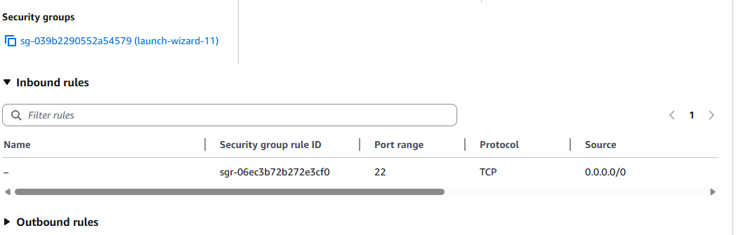

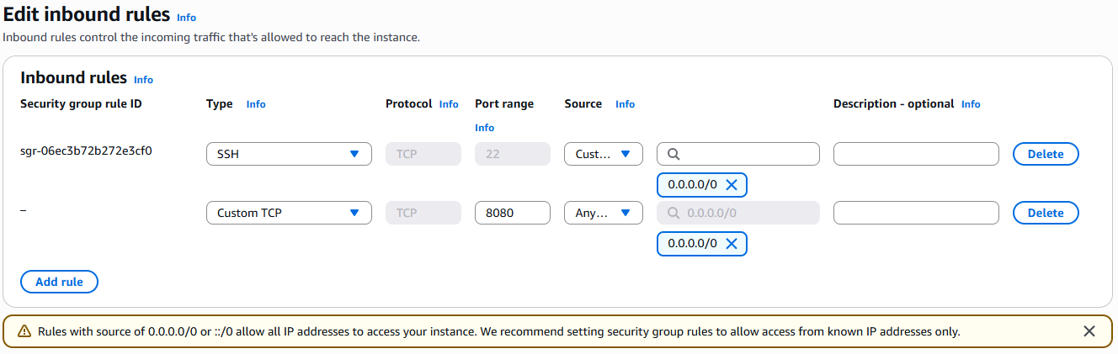

Connect using public IP 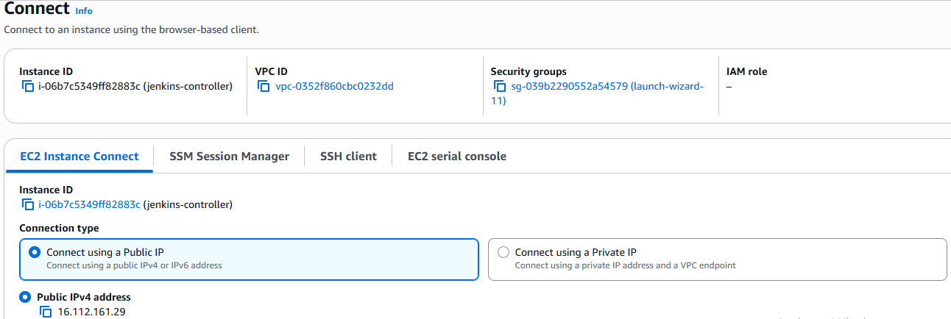

Step 2 – Install Java
Jenkins requires Java to run. Java was installed using:
sudo apt update
sudo apt install openjdk-17-jdk –y
Java installation was verified using: java -version

Step 3 – Install Jenkins on Both Servers
Jenkins was installed on both EC2 instances.
After installation, Jenkins was started using the command: java -jar jenkins.war
(Instead of installing Jenkins using the repository, which caused errors Jenkins was started using the jenkins.war file.)
Then Jenkins was accessed through the browser using: http://EC2_PUBLIC_IP:8080
The initial admin password was retrieved from: /home/ubuntu/.jenkins/secrets/initialAdminPassword
Step 4 – Unlock Jenkins
When Jenkins starts for the first time, it asks for an initial admin password.
The password was retrieved using:
cat ~/.jenkins/secrets/initialAdminPassword
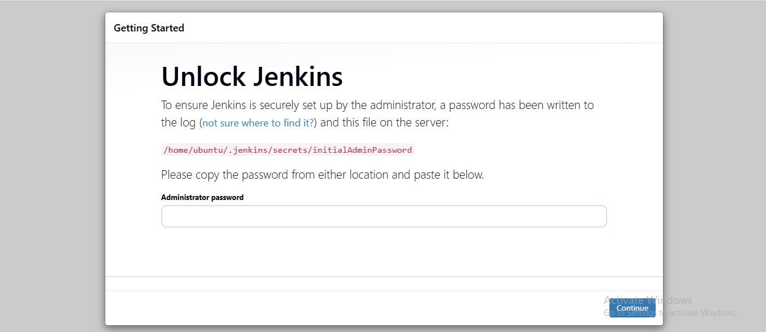
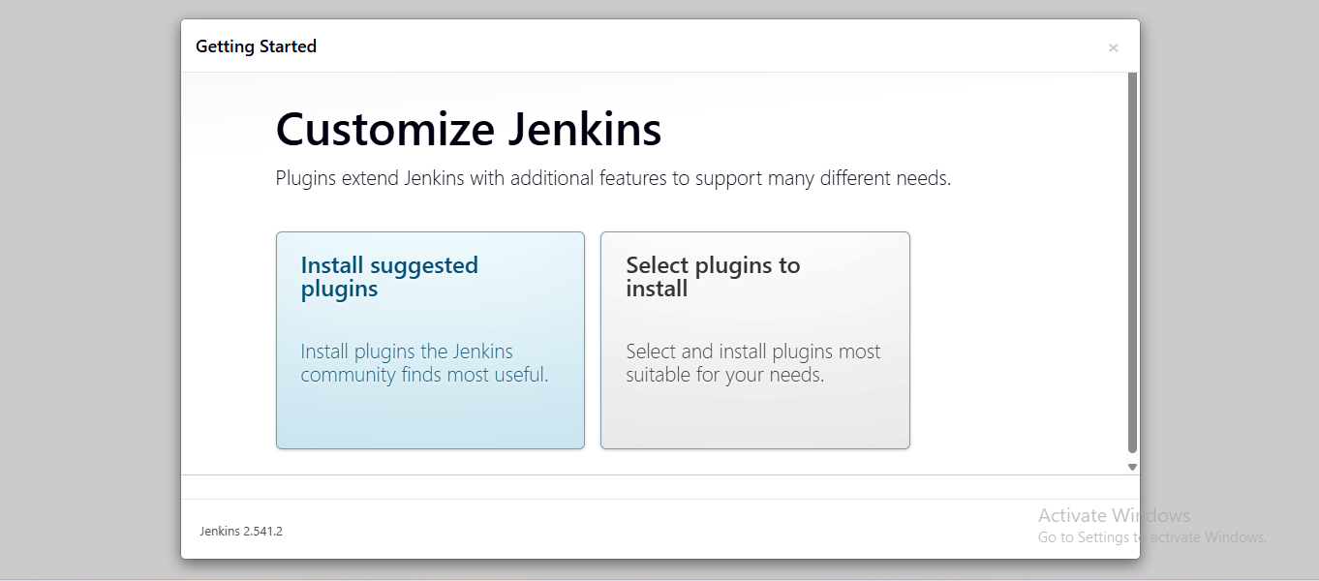

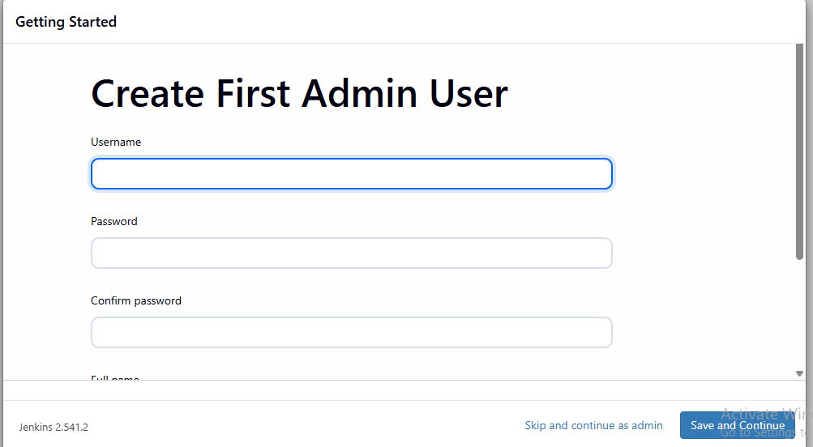

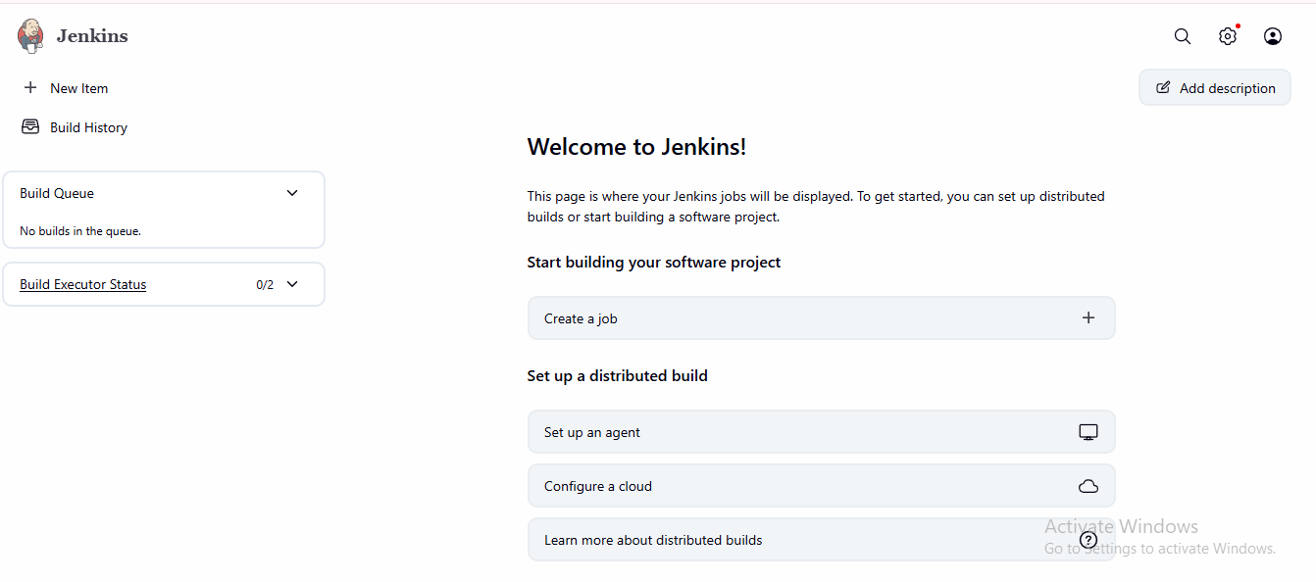

Step 5 – Create Job on Remote Jenkins
On the Remote Jenkins server, a job was created.
Steps:
- Go to Jenkins Dashboard
- Click New Item
- Enter job name: remote-test-job
- Select Freestyle Project
- Click on OK
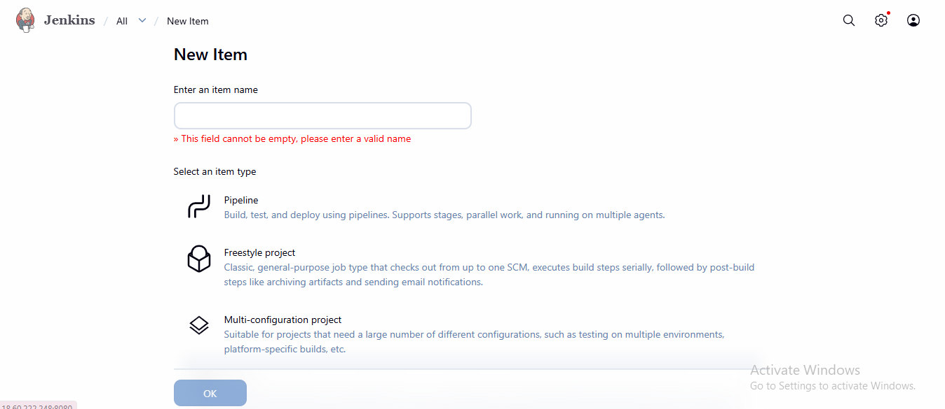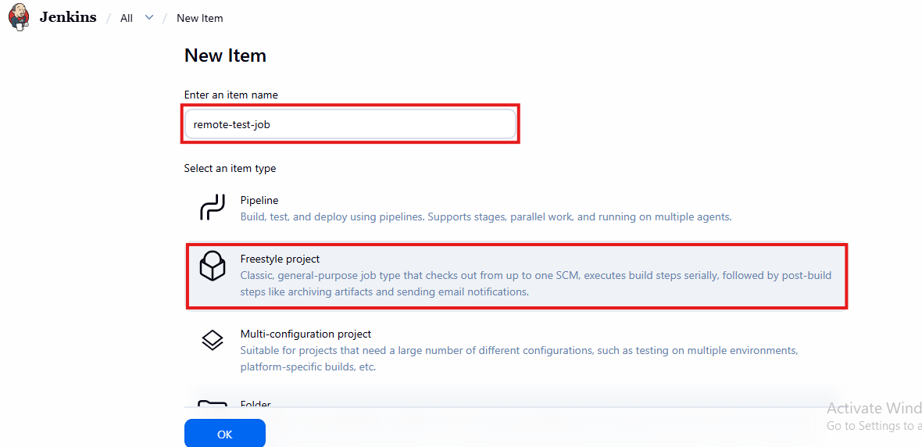
Step 6 – Add a Build Step
Inside the job configuration: Build → Add Build Step → Execute Shell
Commands added:
echo "Hello from Remote Jenkins"
hostname
date

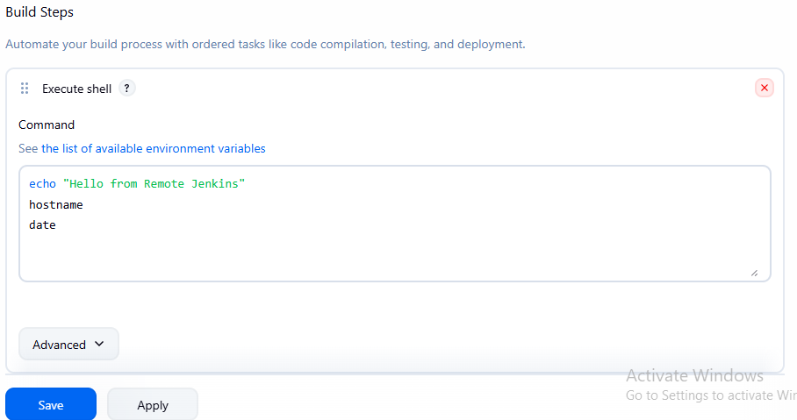

This was used to verify that the job runs successfully.
Step 7 – Test the Job
The job was manually triggered using: Build Now
A successful build appeared in Build History, confirming that Jenkins was functioning correctly.
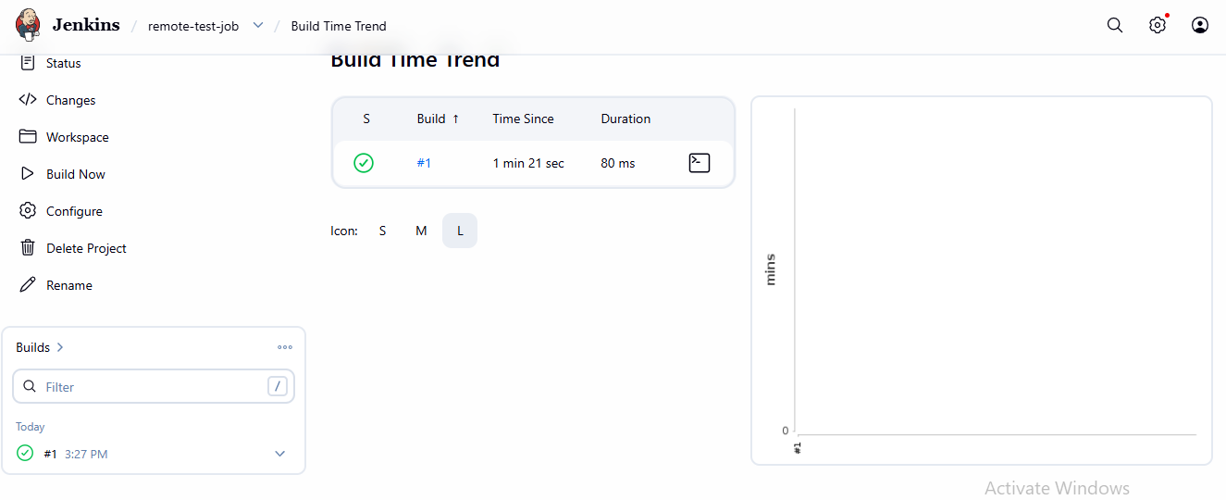
Step 8 – Enable Remote Build Trigger
To allow external triggering of the job:
Enable the option:
Trigger builds remotely (e.g., from scripts)
Authentication token used:
trigger123
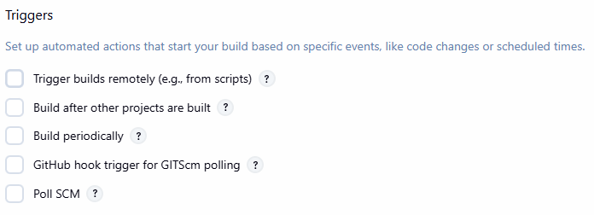
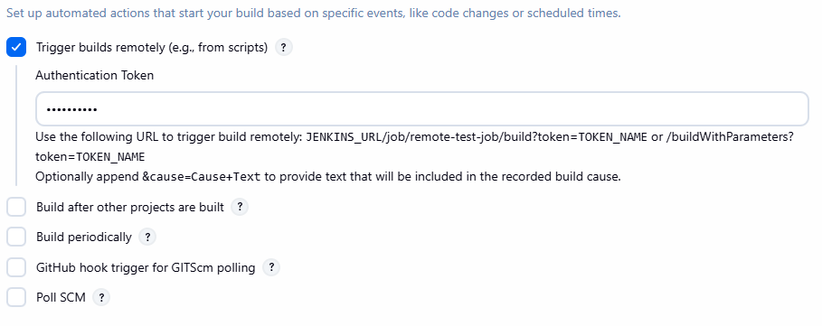

Step 9 – Test Jenkins API Trigger
The remote Jenkins job was triggered using the API URL:
http://REMOTE_EC2_IP:8080/job/remote-test-job/build?token=trigger123
When opened in the browser, a new build appeared in Build History.

Step 10 – Create Controller Job
On the Controller Jenkins server, another job was created.
Steps:
- Click New Item
- Job name: controller-trigger-job
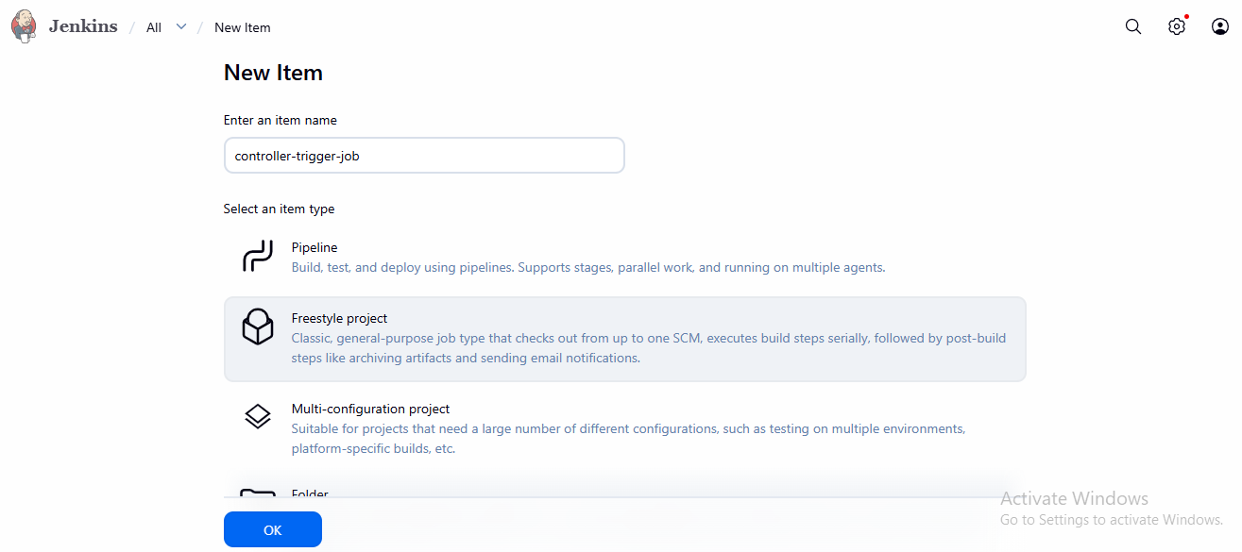
- Select Freestyle Project

Step 11 – Trigger Remote Jenkins Using CURL
Inside the controller job: Build → Execute Shell

Command used:
curl http://REMOTE_EC2_IP:8080/job/remote-test-job/build?token=trigger123
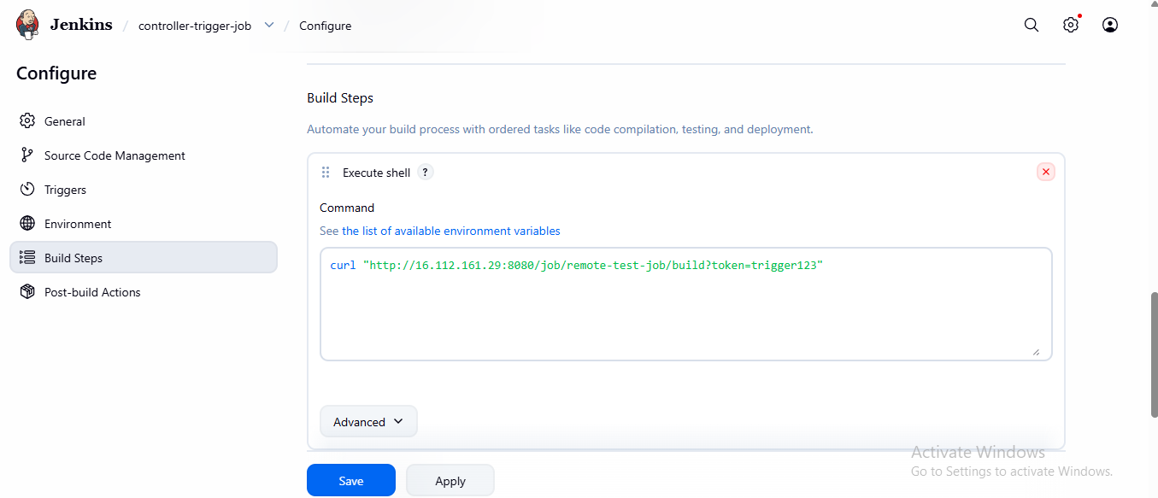

Step 12 – Test Controller Job
When the controller-trigger-job was executed:
- Controller Jenkins executed the curl command
- The command called the Remote Jenkins API
- Remote Jenkins started a new build automatically (a new build automatically appeared in the Remote Jenkins Build History)
This confirmed successful communication between both Jenkins servers.
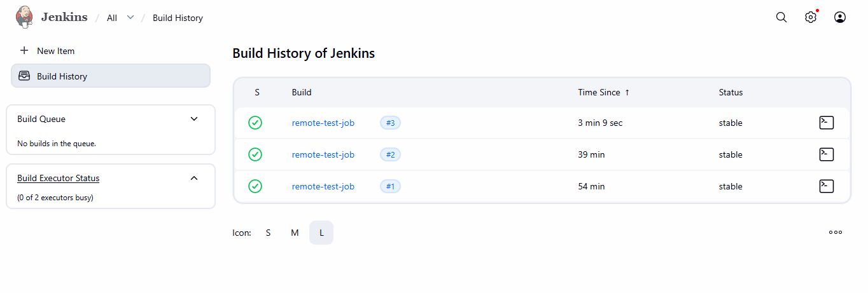

Errors Faced During Implementation
During the project, several issues were encountered and resolved.

Jenkins Repository GPG Key Error
Error:
NO_PUBKEY 7198F4B714ABFC68
The repository is not signed
Cause:
The Jenkins repository key was missing in the Ubuntu system.
Solution:
Instead of continuing with the repository installation, Jenkins was started directly using the jenkins.war file.

Jenkins Service Not Found
Error:
Failed to start jenkins.service: Unit jenkins.service not found
Cause:
Jenkins was not installed as a system service.
Solution:
Jenkins was started manually using:
java -jar jenkins.war

Jenkins Page Not Loading
Error:
This site can't be reached
Cause:
Jenkins process was not running or the terminal session was closed.
Solution:
Jenkins was restarted and kept running in the terminal.

Could Not Resolve Host Error
Error:
curl: (6) Could not resolve host: REMOTE_IP
Cause:
The placeholder REMOTE_IP was used instead of the actual EC2 public IP.
Solution:
Replaced it with the correct EC2 public IP.

Jenkins Stopped After Closing Terminal
Problem:
When Jenkins was started using:
java -jar jenkins.war
closing the terminal stopped Jenkins.
Solution:
Jenkins must run continuously in the terminal or using background processes like:
nohup

Outcome
The project successfully demonstrated a distributed Jenkins setup on AWS where one Jenkins server triggers builds on another Jenkins server using the Jenkins REST API.
This simulates a real DevOps environment where build workloads can be distributed across multiple servers.

